Deployment & Usage Instructions
Glass V2.3.2

Version: 2.3.2
Last Updated: 01/10/2026

Contents
1 Introduction 4
2 Getting Started 4
2.1 Built-with 4
2.2 Pre-requisite 4
3 Installation 5
3.1 On Splunk Single Instance Setup 5
3.1.1 Login to Splunk web interface 5
3.1.2 Install the Glass app 5
3.1.3 Configure the Glass app 7
3.2 On Splunk Cluster Setup 12
3.2.1 Login to Splunk Manager/Master Node web interface 12
3.2.2 Install the Glass app 13
3.2.3 Configure the Glass app 15
3.2.4 Deploy the Glass app to Peer Nodes 20
3.2.5 Deploy the Glass app to Search Head Node 23
4 Usage Instructions 23
4.1 Opening the Glass App on Splunk UI 23
4.2 Running “archive” command 25
4.3 Running “catalog” command 25
4.4 Running “restore” command 26
4.5 Confirming the Restored Data in Splunk 27
4.5.1 Steps to run the Splunk Search query to confirm the restored Data from Splunk Search: 27
4.5.2 Steps to confirm the restored data from the Splunk CLI: 28
5 Operational Notes 28
6 Troubleshooting 29
6.1 Restart Splunk instance 29
7 Uninstall and cleanup 30
7.1 Splunk Single Instance Setup 30
7.2 Splunk Cluster Setup 31
7.2.1 On Master and Peer Indexer Nodes 31
7.2.2 On Search Head Node 33
8 Acknowledgement 33

Introduction
This document contains the installation instruction and usage guide for Glass App for Splunk. Most Economical archiving for large Splunk implementations.
Glass is an archiving solution that is designed to work when Splunk policies in indexes.conf results in data being transferred to Frozen tier. Once the data is available in Frozen tier, Glass App can archive the data from there to a Remote storage and restore it back to Splunk when needed.
Since Glass App only works with Frozen data, it does not directly touch any indexes of Splunk and therefore does not impact any of the existing ingestion flows into Splunk. This approach means no runtime degradation to performance of currently running Splunk systems is caused by using the Glass App services.

Getting Started
This section provides the steps to install and configure the Glass app.

Built-with
- Python - https://www.python.org/
- Boto3 - https://pypi.org/project/boto3/
- Splunk App Guidelines - https://dev.splunk.com/enterprise/docs/developapps/createapps/appanatomy

Pre-requisite
- Splunk instance with indexes configured to move the data to the frozen tier (Index should have frozen directory or frozen script configured)
- This app is supported on Splunk versions 9.x and 10.x.
- This app is supported by Splunk on Linux Operating Systems.
- Instance must have access to internet
  - To download the dependencies
  - And to access the external storage system for data archive
- Splunk user with adequate roles (splunk-system-role) and permissions to invoke the Splunk REST APIs. You can use the default admin user for testing and validation. This user should have permission to create an Index and data ingestion.
- External S3 compatible storage (AWS S3 Glacier, Geyser Data, IBM Deep Archive, Quantum, Spectra) to archive the data (Splunk buckets from frozen tier).
- External S3 compatible Disk based storage to archive the partitioned Catalog DB which contains the metadata of the archived Splunk buckets.
- Storage systems must be accessible through Splunk instance.
- The below configuration is present in Splunk Server’s server.conf by default, in case if it is changed explicitly please reset it to the below default value before Glass App installation.
[httpServer]
crossOriginSharingPolicy = http://localhost:8000/
crossOriginSharingHeaders = Authorization, Content-Type
allowBasicAuth = true
- Google Chrome or Microsoft Edge browsers to access the Glass App from UI.

Installation

On Splunk Single Instance Setup
For installation, you are provided with deliverable zip (glass_app-2.3.2.tar.gz).

Login to Splunk web interface
- Access the Splunk web UI through browser and login

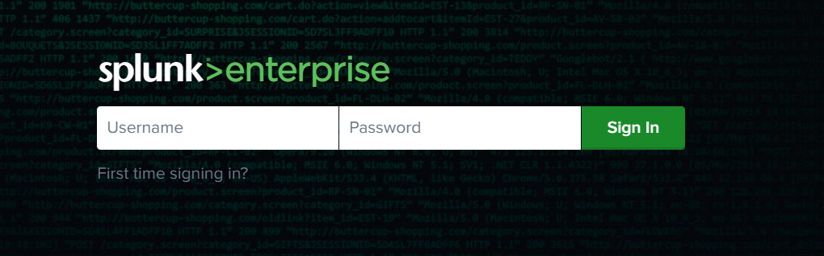

- After successfully logging in, you will be redirected to the Splunk homepage

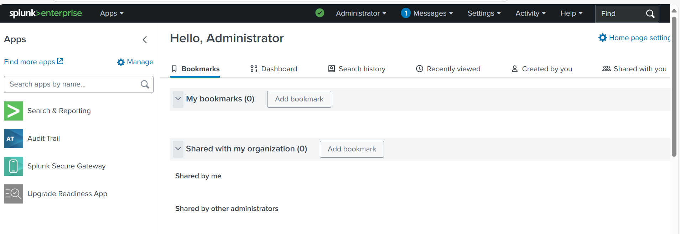

Install the Glass app
- Go to the manage app page

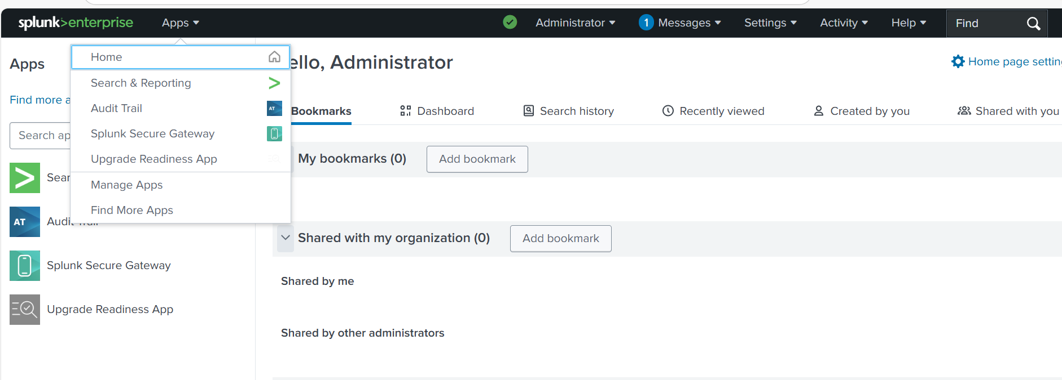
1. Click on Apps
2. Click on Manage Apps

- After clicking on Manage Apps, you will be directed to Apps page
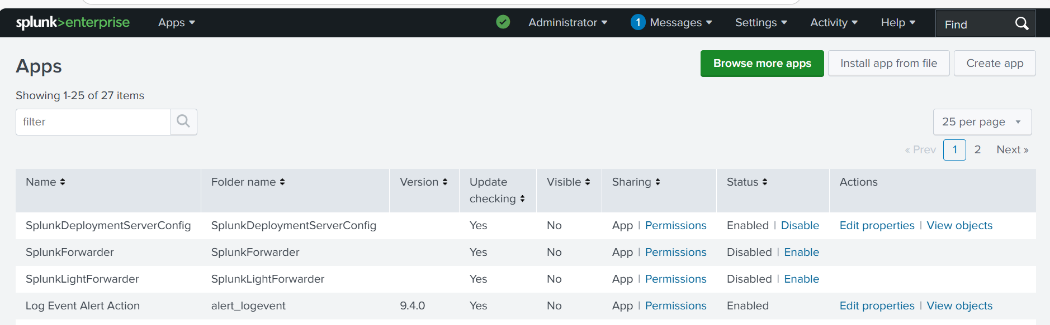
3. Click on Install app from file

- After clicking on Install from file, you will be directed to upload app page

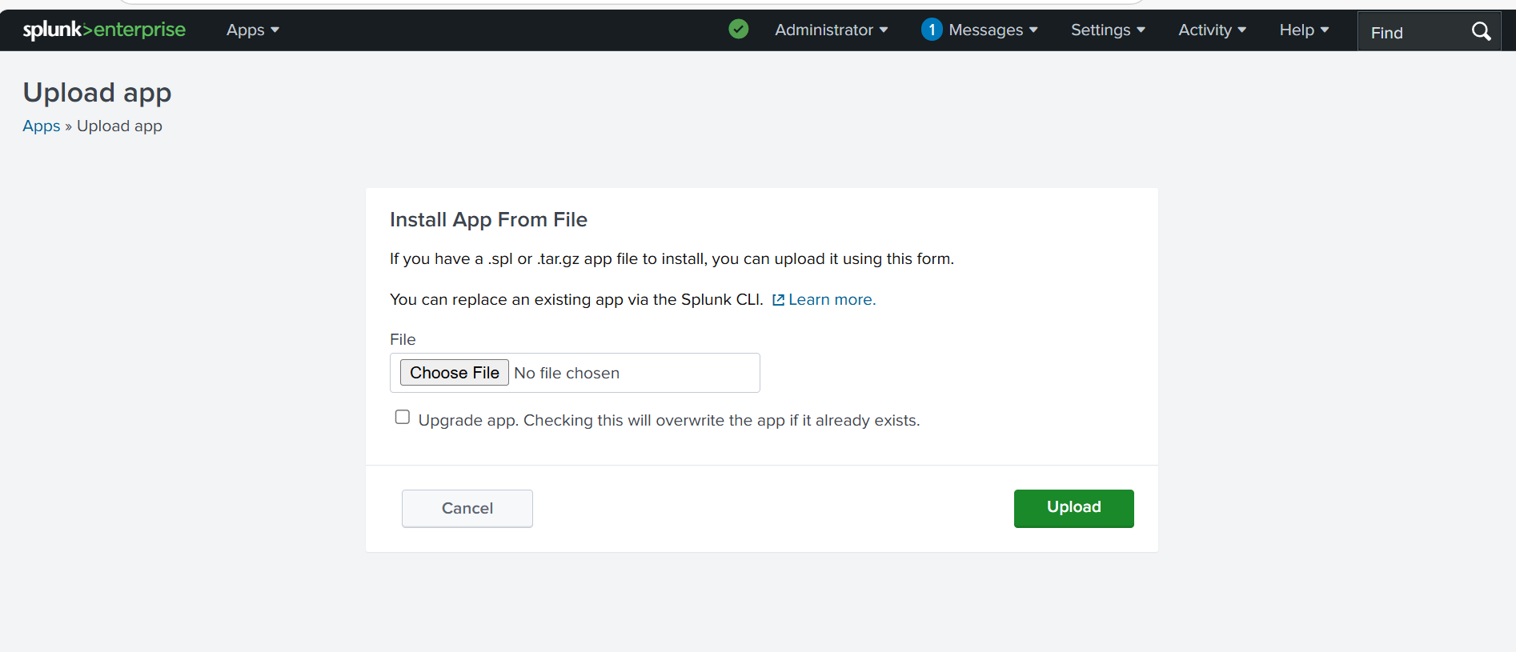
4. Click on Choose File
5. Select the glass_app-2.3.2.tar.gz
6. Click on upload after file selection

- After successful upload of the Glass app, you will be redirected to the Glass App’s setup page to complete the App’s configuration.
If you select “Set up now” then continue with step 3 of section 3.1.3 to continue with the app configuration.
If you select “Setup Later” then refer to section 3.1.3 for configuring the app later.

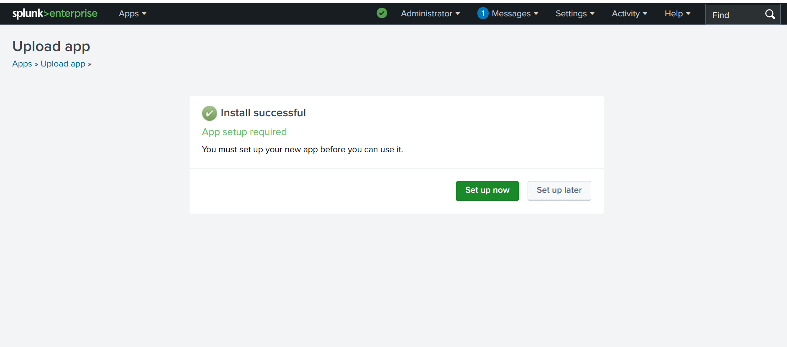

Note: Splunk Server restart might be required after App installation to display the app icons and images properly.

Configure the Glass app
- Login again to Splunk instance after successful restart and installation

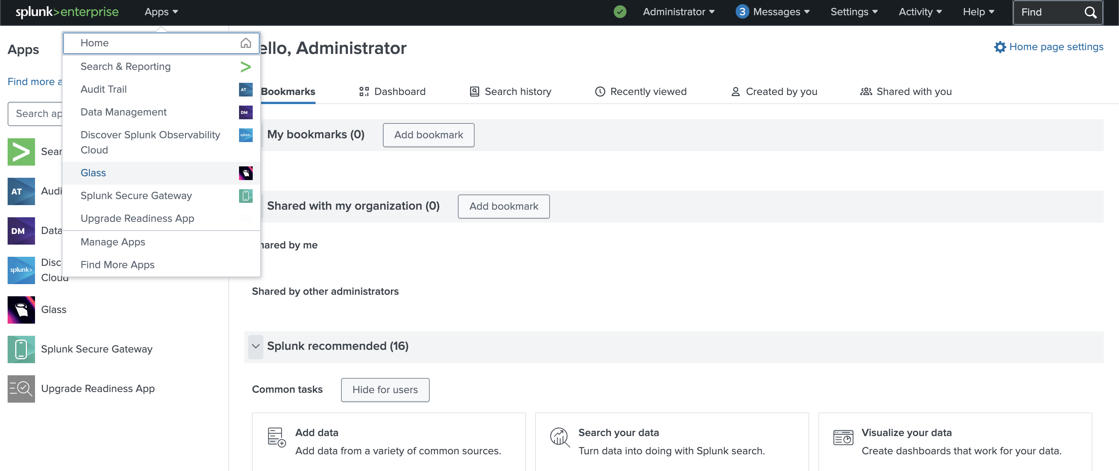
7. Glass app will be listed in the Apps section after successful installation

- Select the Glass app, you will be directed to configuration page
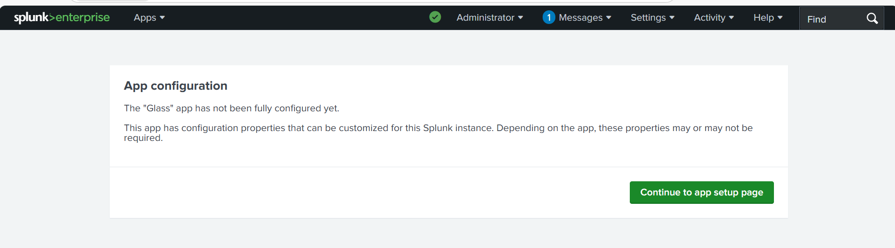
8. Go to the setup page and provide all the configuration. Only for the first time after installation

- Input all the configuration details
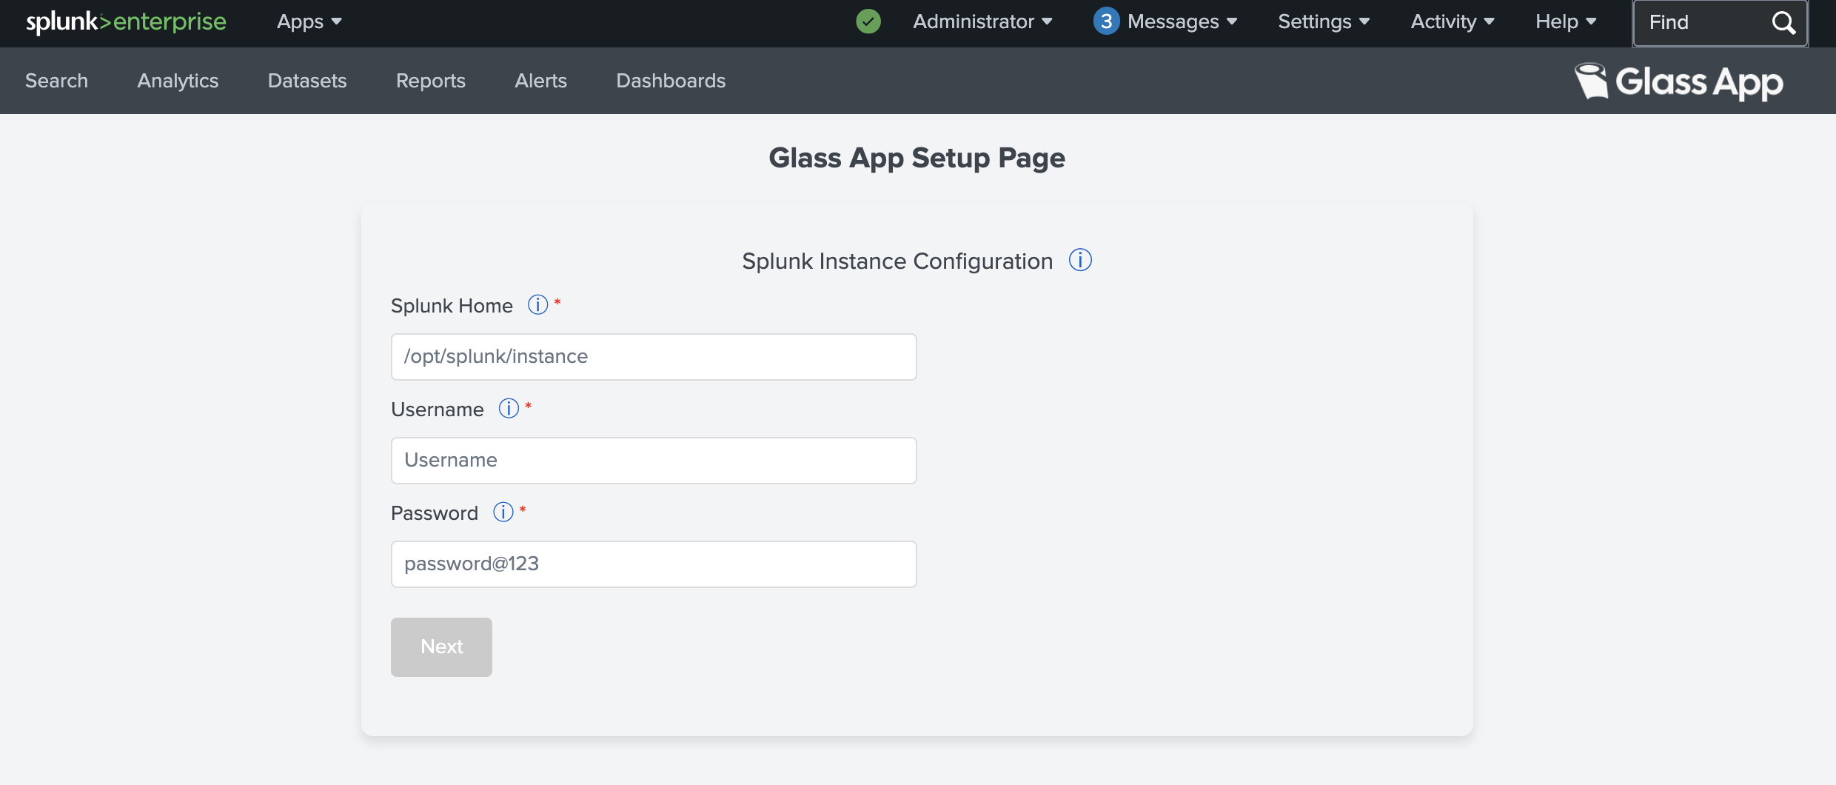
This section is to input Splunk instance details
Splunk Home = Value of $SPLUNK_HOME (Installation directory of Splunk)
Username & Password = Splunk User credentials

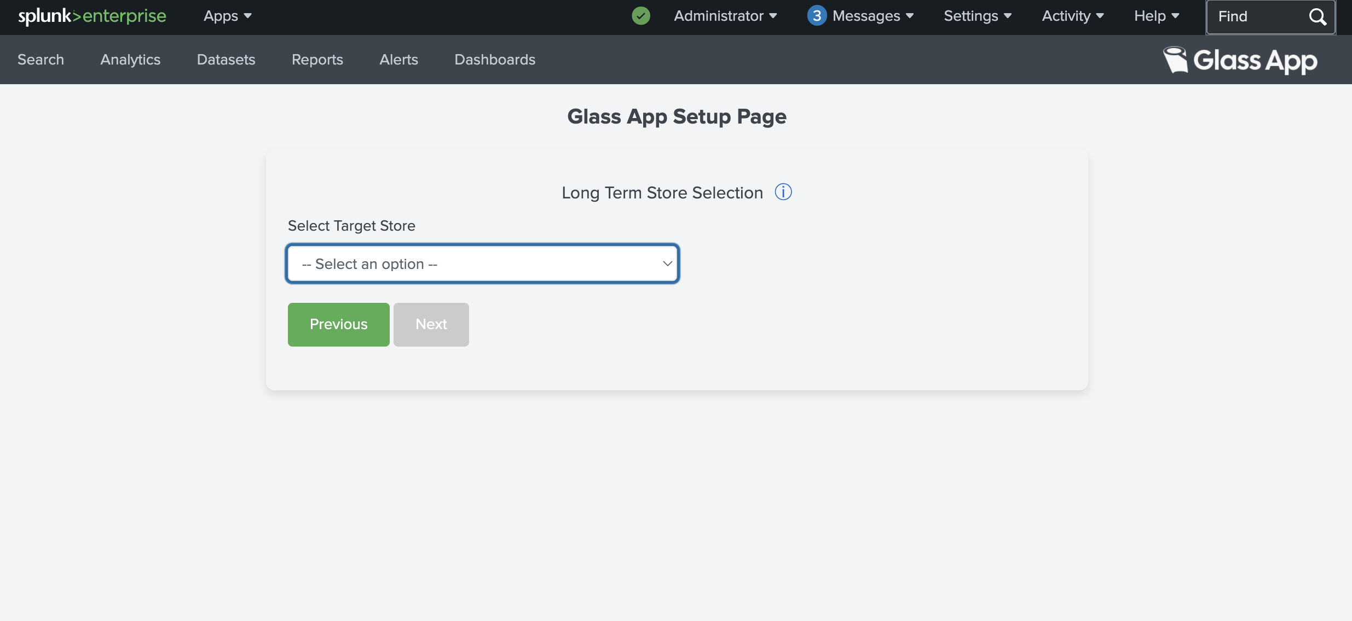
This section is to Select Long term Storage Selection
Select the long-term storage from the below options in the Dropdown:
- AWS S3
- Geyser Data
- IBM Deep Archive
- Quantum ActiveScale
- Spectra BlackPearl

**Note: It is recommended to provide the Storage related details like Bucket Name and Endpoint URL only once at the time of configuration and should not be updated later (specially once the Glass app archive process has been executed at least once) as it will cause issues like missing data in Catalog and Restore commands.

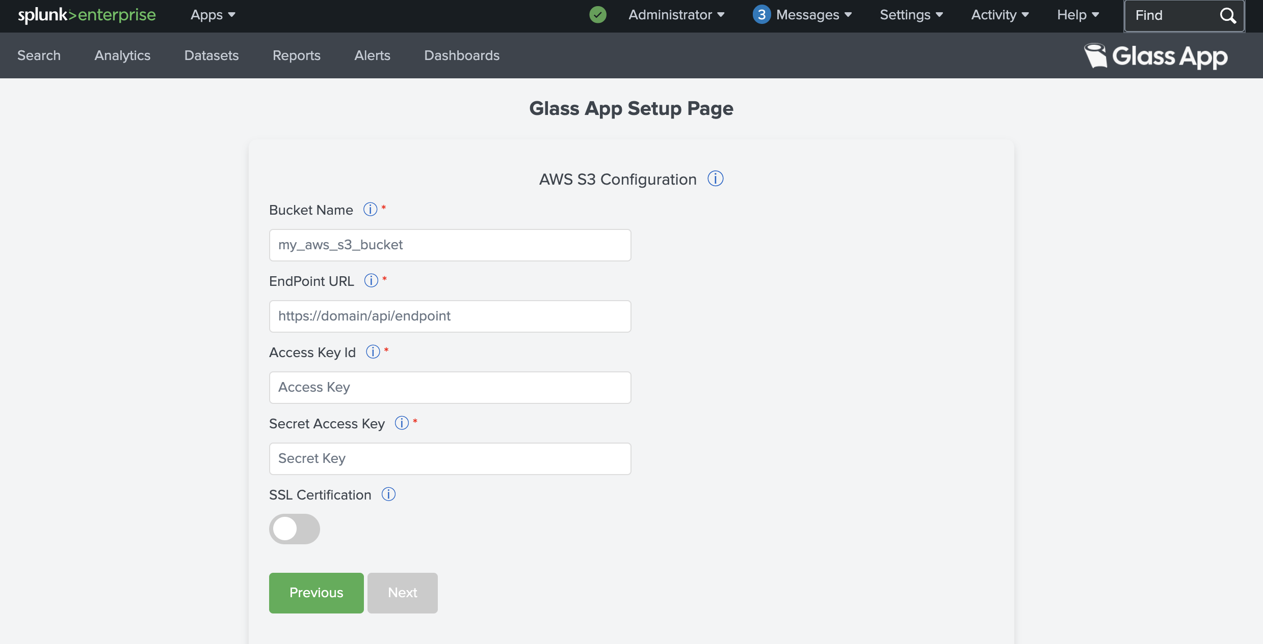
This section is to provide AWS S3 storage configuration
Bucket Name = Name of the bucket
EndPoint URL = Bucket endpoint URL
Access Key = Access Key to access the bucket
Secret Access Key = Secret Key to access the bucket

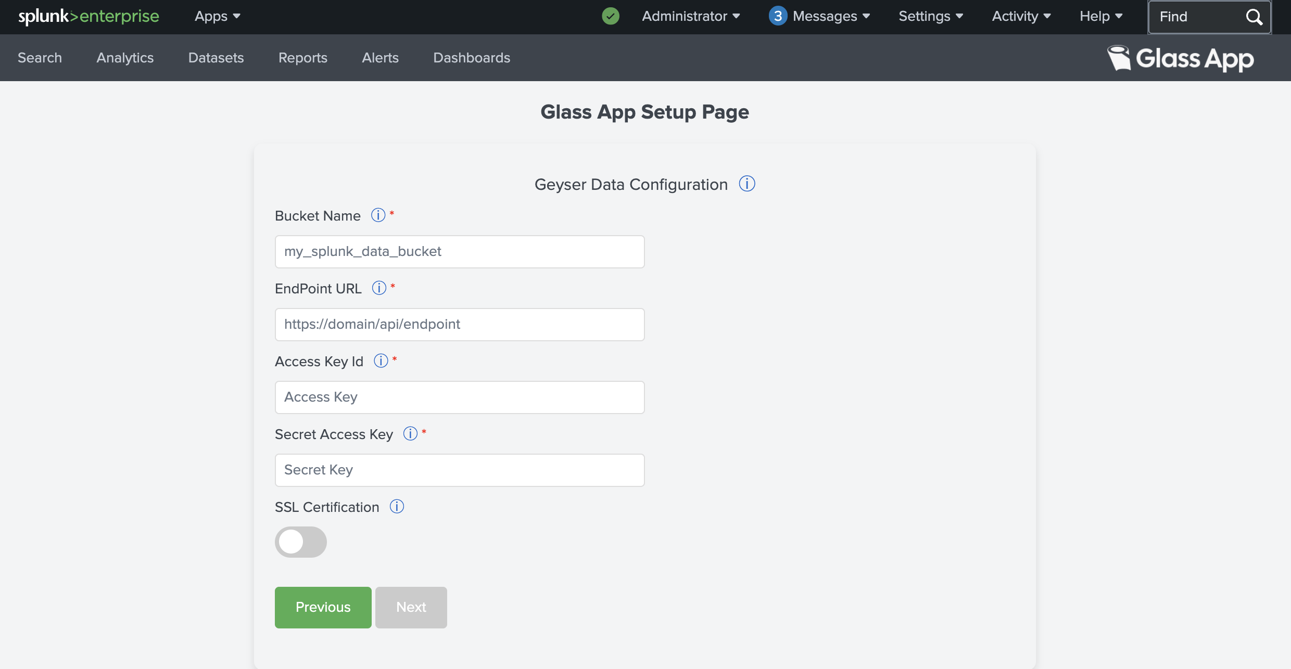
This section is to provide Geyser Data storage configuration
Bucket Name = Name of the bucket
EndPoint URL = Bucket endpoint URL
Access Key = Access Key to access the bucket
Secret Access Key = Secret Key to access the bucket
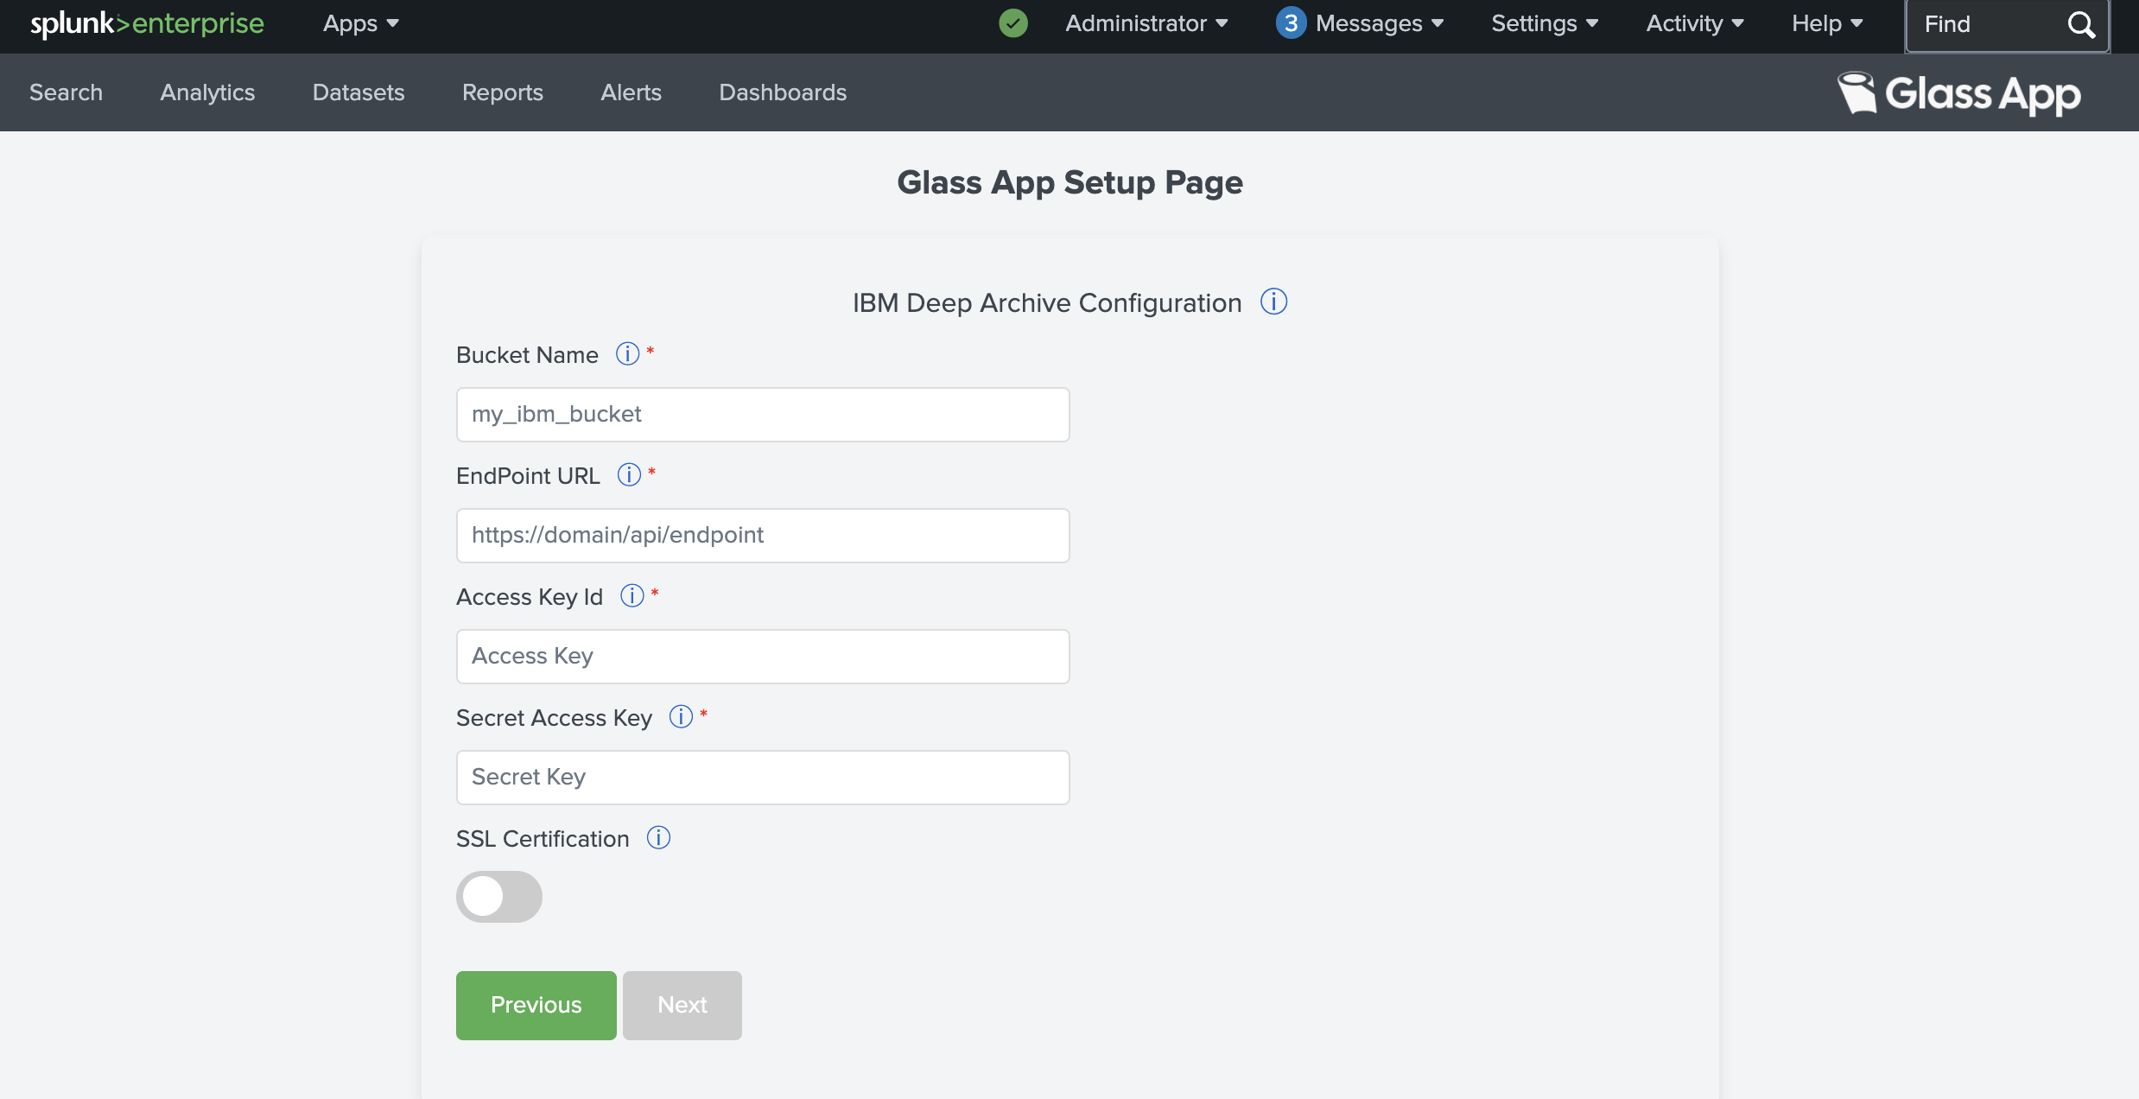
This section is to provide IBM Deep Archive storage configuration
Bucket Name = Name of the bucket
EndPoint URL = Bucket endpoint URL
Access Key = Access Key to access the bucket
Secret Access Key = Secret Key to access the bucket

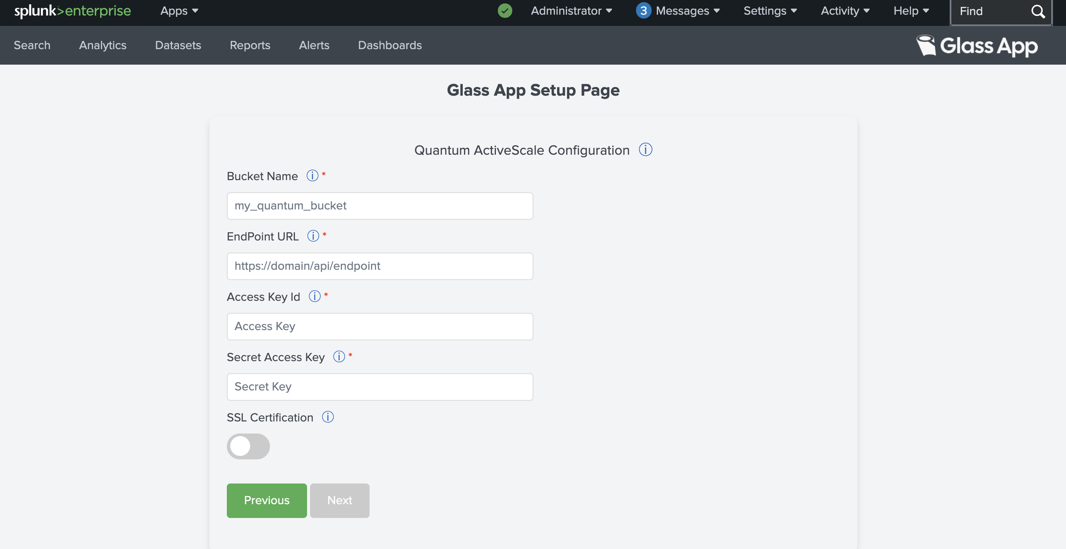
This section is to provide Quantum ActiveScale storage configuration
Bucket Name = Name of the bucket
EndPoint URL = Bucket endpoint URL
Access Key = Access Key to access the bucket
Secret Access Key = Secret Key to access the bucket

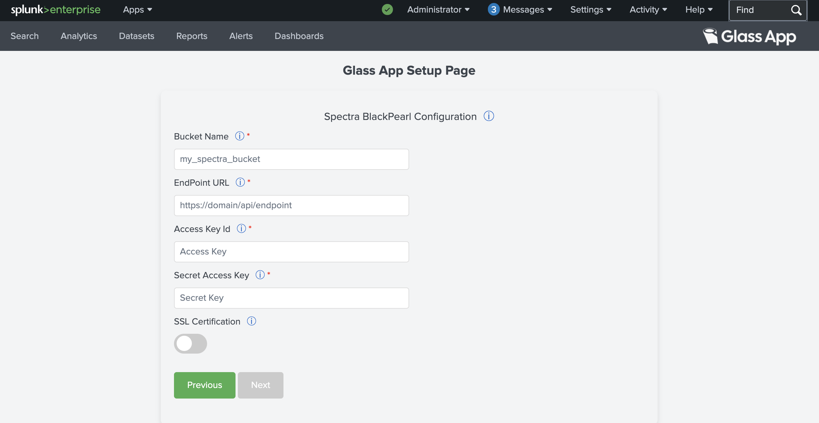
This section is to provide Spectra BlackPearl bucket configuration
Bucket Name = Name of the bucket
EndPoint URL = Bucket endpoint URL
Access Key = Access Key to access the bucket
Secret Access Key = Secret Key to access the bucket

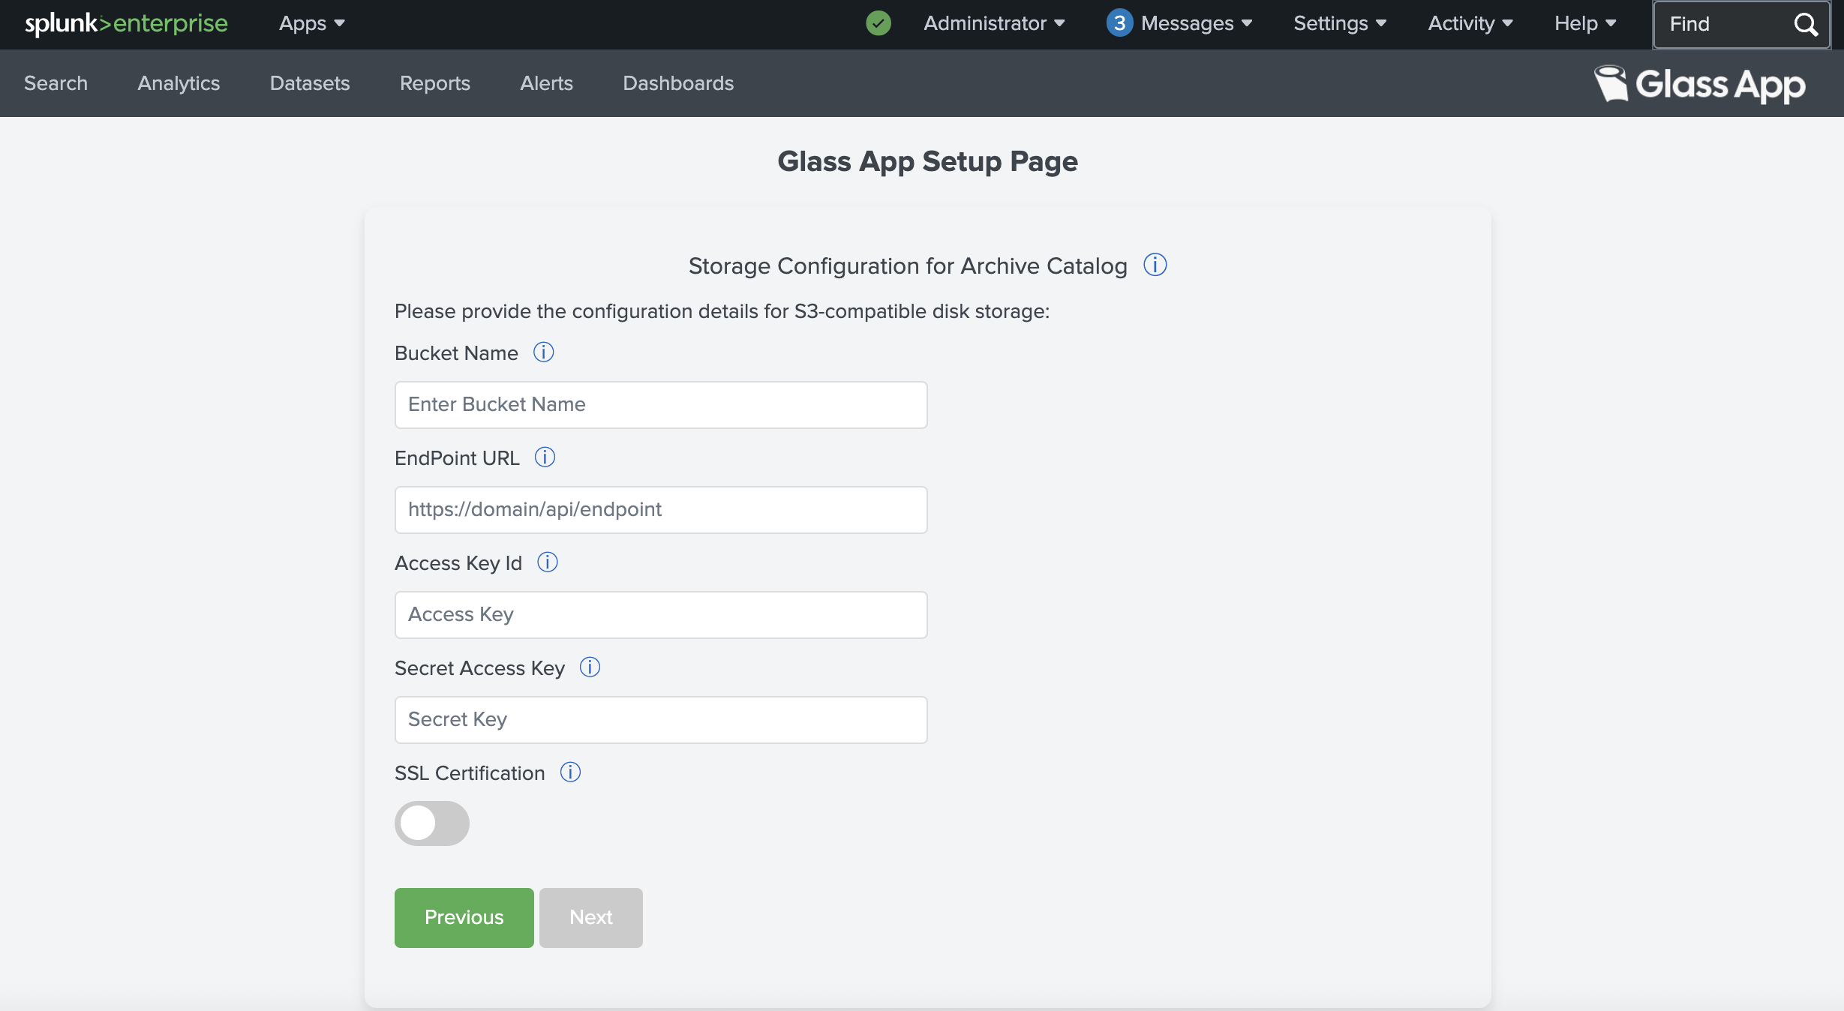
This section is to provide S3 Compatible Disk storage configuration for Catalog DB archive
Bucket Name = Name of the bucket
EndPoint URL = Bucket endpoint URL
Access Key = Access Key to access the bucket
Secret Access Key = Secret Key to access the bucket

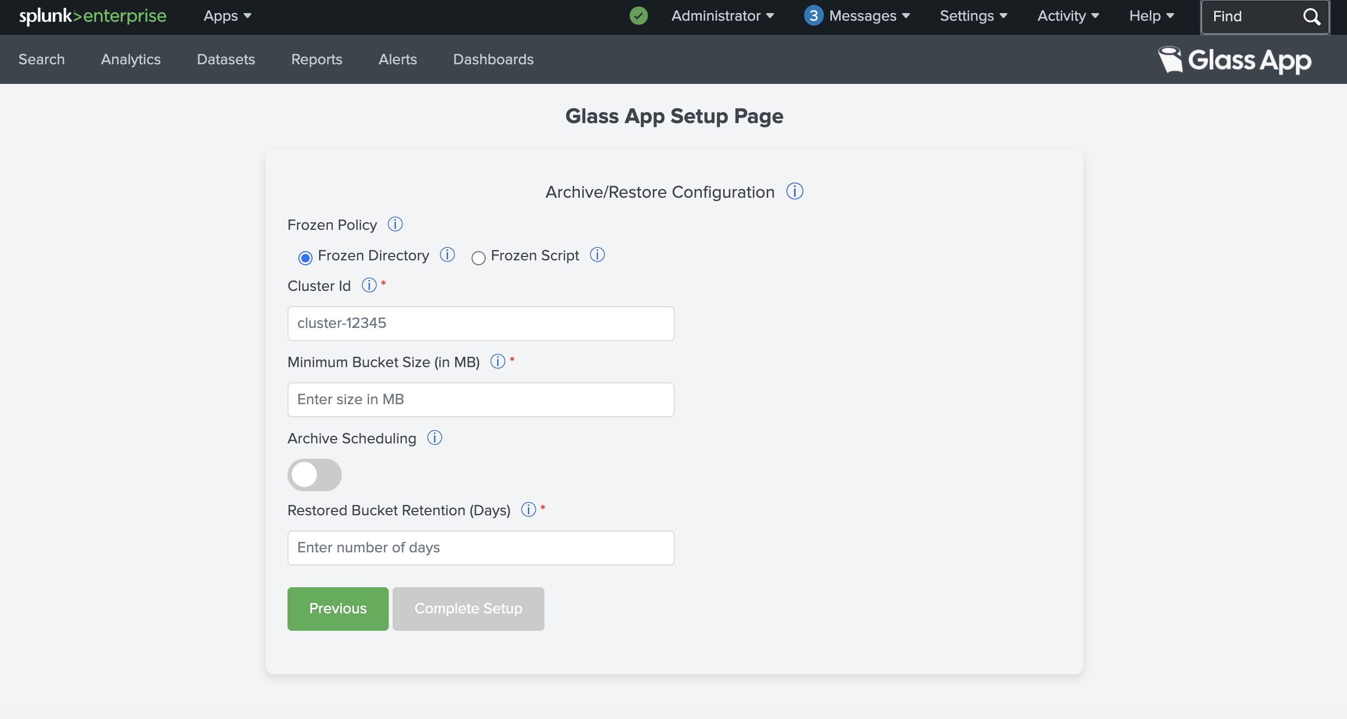
9. Submit the page after providing all the details

This section is to provide configuration for Glass app archive script
Frozen Directory Base Path = Base path configured for Splunk coldToFrozenScript. (Only used when “Frozen Script” is selected)
Cluster Id = Unique identification for each cluster
Minimum Bucket Size = Bucket size qualified for immediate archive
Archive replicated buckets (If set to yes, replicated buckets are also archived in case of Cluster Setup, skipped otherwise)
Schedule Interval = At which archive script will be executed
Restored Bucket Retention (Days) = Number of days after which restored buckets from thawed db should be cleaned.

** When “Frozen Script” option is selected, the coldToFrozenScript provided inside the Glass App package should be used and configured as per Splunk policies. The base path which is used inside the script should be added as input in the “Frozen Directory Base Path” field.
- Message will be shown once configuration is done successfully and you will be redirected to Glass app

On Splunk Cluster Setup
For installation, you are provided with a deliverable zip (glass_app-2.3.2.tar.gz).

Login to Splunk Manager/Master Node web interface
- Access the Splunk web UI through browser and login

- After successfully logging in, you will be directed to the Splunk homepage

Install the Glass app
1. Click on Apps
- Go to the manage app page

2. Click on Manage Apps

- After clicking on Manage Apps, you will be directed to Apps page
3. Click on Install app from file

- After clicking on Install from file, you will be directed to upload app page

4. Click on Choose File
5. Select the glass_app-2.3.2.tar.gz
6. Click on upload after file selection

- After successful upload of the Glass app, you will be redirected to the Glass App’s setup page to complete the App’s configuration. Click on “Set up now” and continue with step 3 of section 3.2.3.
If you select “Setup Later” then refer to section 3.2.3 for configuring the app later.

Note: Splunk Server restart might be required after App installation to display the app icons and images properly.

Configure the Glass app
Note: In case of Splunk Cluster, configuration added on the setup page should be the same on Peer nodes as well as Search Head Nodes.
Configuration for the Peer nodes should be done from the Master Node only.

- Login again to Splunk instance after successful restart and installation

7. Glass app will be listed in the Apps section after successfully installation

- Select the Glass app, you will be directed to configuration page

8. Go to the setup page and provide all the configuration. Only for the first time after installation

- Input all the configuration details

This section is to input Splunk instance details
Splunk Home = Value of $SPLUNK_HOME (Installation directory of Splunk)
Username & Password = Splunk User credential

This section is to Select Long term Storage Selection
Select the long-term storage from the below options in the Dropdown:
- AWS S3
- Geyser Data
- IBM Deep Archive
- Quantum ActiveScale
- Spectra BlackPearl

**Note: It is recommended to provide the Storage related details like Bucket Name and Endpoint URL only once at the time of configuration and should not be updated later (specially once the Glass app archive process has been executed at least once) as it will cause issues like missing data in Catalog and Restore commands.

This section is to provide AWS S3 storage configuration
Bucket Name = Name of the bucket
EndPoint URL = Bucket endpoint URL
Access Key = Access Key to access the bucket
Secret Access Key = Secret Key to access the bucket

This section is to provide Geyser Data storage configuration
Bucket Name = Name of the bucket
EndPoint URL = Bucket endpoint URL
Access Key = Access Key to access the bucket
Secret Access Key = Secret Key to access the bucket

This section is to provide IBM Deep Archive storage configuration
Bucket Name = Name of the bucket
EndPoint URL = Bucket endpoint URL
Access Key = Access Key to access the bucket
Secret Access Key = Secret Key to access the bucket

This section is to provide Quantum ActiveScale storage configuration
Bucket Name = Name of the bucket
EndPoint URL = Bucket endpoint URL
Access Key = Access Key to access the bucket
Secret Access Key = Secret Key to access the bucket

This section is to provide Spectra BlackPearl storage configuration
Bucket Name = Name of the bucket
EndPoint URL = Bucket endpoint URL
Access Key = Access Key to access the bucket
Secret Access Key = Secret Key to access the bucket

This section is to provide S3 Compatible Disk storage configuration for Catalog DB archive
Bucket Name = Name of the bucket
EndPoint URL = Bucket endpoint URL
Access Key = Access Key to access the bucket
Secret Access Key = Secret Key to access the bucket

9. Submit the page after providing all the details

This section is to provide configuration for Glass app archive script
Frozen Directory Base Path = Base path configured for Splunk coldToFrozenScript. (Only used when “Frozen Script” is selected)
Cluster Id = Unique identification for each cluster
Minimum Bucket Size = Bucket size qualified for immediate archive
Archive replicated buckets (If set to yes, replicated buckets are also archived in case of Cluster Setup, skipped otherwise)
Schedule Interval = At which archive script will be executed
Restored Bucket Retention (Days) = Number of days after which restored buckets from thawed db should be cleaned.

** When “Frozen Script” option is selected, the coldToFrozenScript provided inside the Glass App package should be used and configured as per Splunk policies. The base path which is used inside the script should be added as input in the “Frozen Directory Base Path” field.
- Message will be shown once configuration is done successfully and you will be redirected to Glass app
** Note: Keep the Glass App installed on the Master node, as it will be required to manage the back and restore of the Glass Catalog on Peer nodes in case of any node failure.

Deploy the Glass app to Peer Nodes
- Go to the Splunk CLI of the Manager/Master node.
- Switch User to splunk:
su - splunk
- Copy the glass_app installed using Section 3.2.2 and 3.2.3, from “$Splunk_Home/etc/apps” to location "$Splunk_Home/etc/manager-apps” or “$Splunk_Home/etc/master-apps” (in case of old Splunk versions) on the Manager/Master node.
cp -r /opt/splunk/etc/apps/glass_app /opt/splunk/etc/manager-apps/

**Note: Do not remove the glass_app from $SPLUNK_HOME/etc/apps on the Cluster Manager node after it has been deployed to the Cluster Peer nodes.
The app must remain on the Manager node to facilitate future upgrades. During an upgrade, the application should first be upgraded on the Cluster Manager node, after which the updated version can be propagated to the Peer nodes through the cluster deployment process.
.

- After performing the above steps, the Glass app should be present in “$Splunk_Home/etc/manager-apps” or “$Splunk_Home/etc/master-apps” (for older Splunk versions). Only the changes inside the manager-apps or master-apps are replicated to peers.

- To push changes from Manager Node to Peer Indexer nodes, use Manager node UI and click on “Settings” and select “Indexer Clustering”

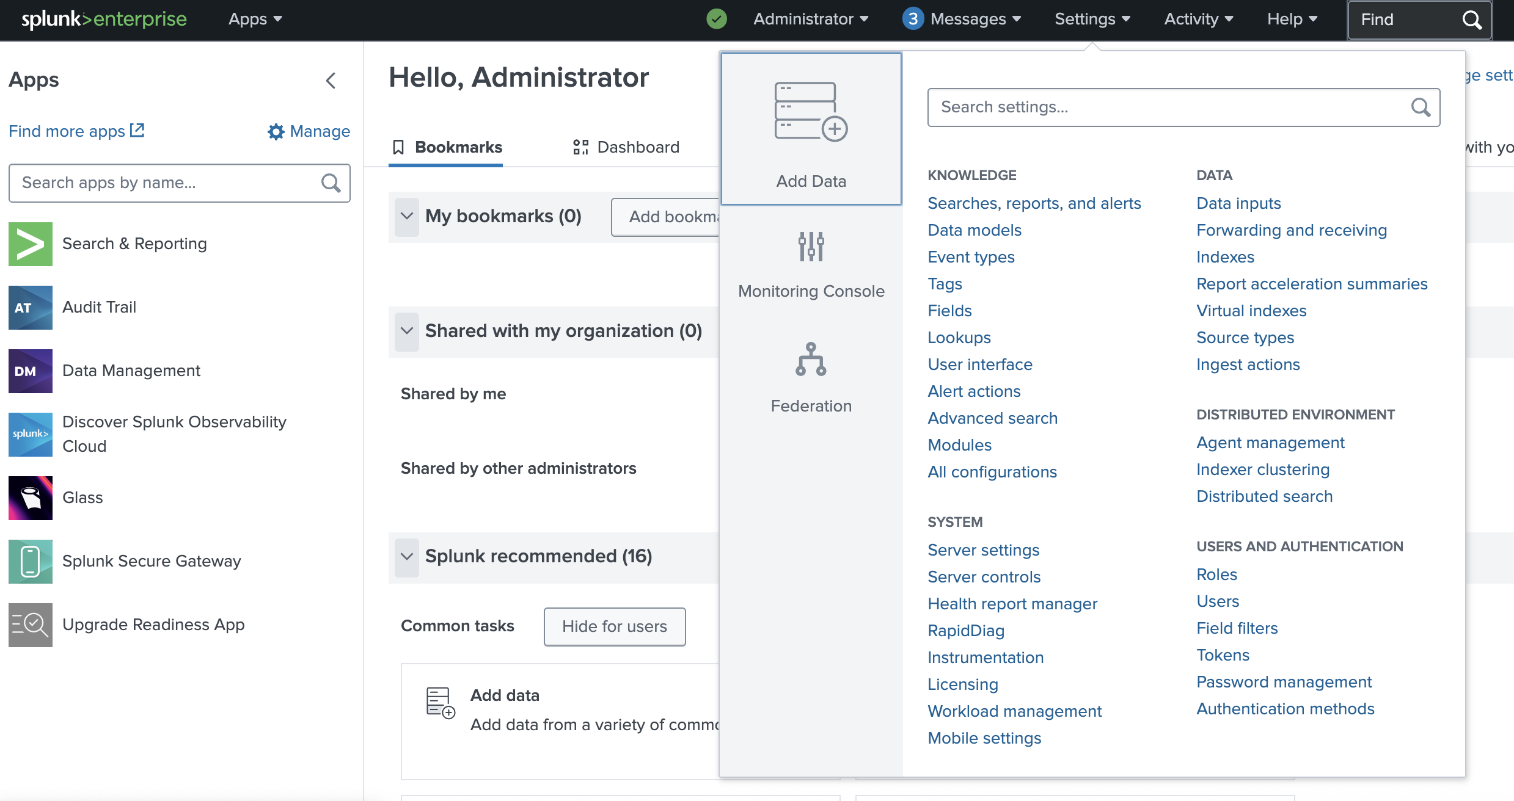

- Click on "Edit" and select "Configuration Bundle Actions"

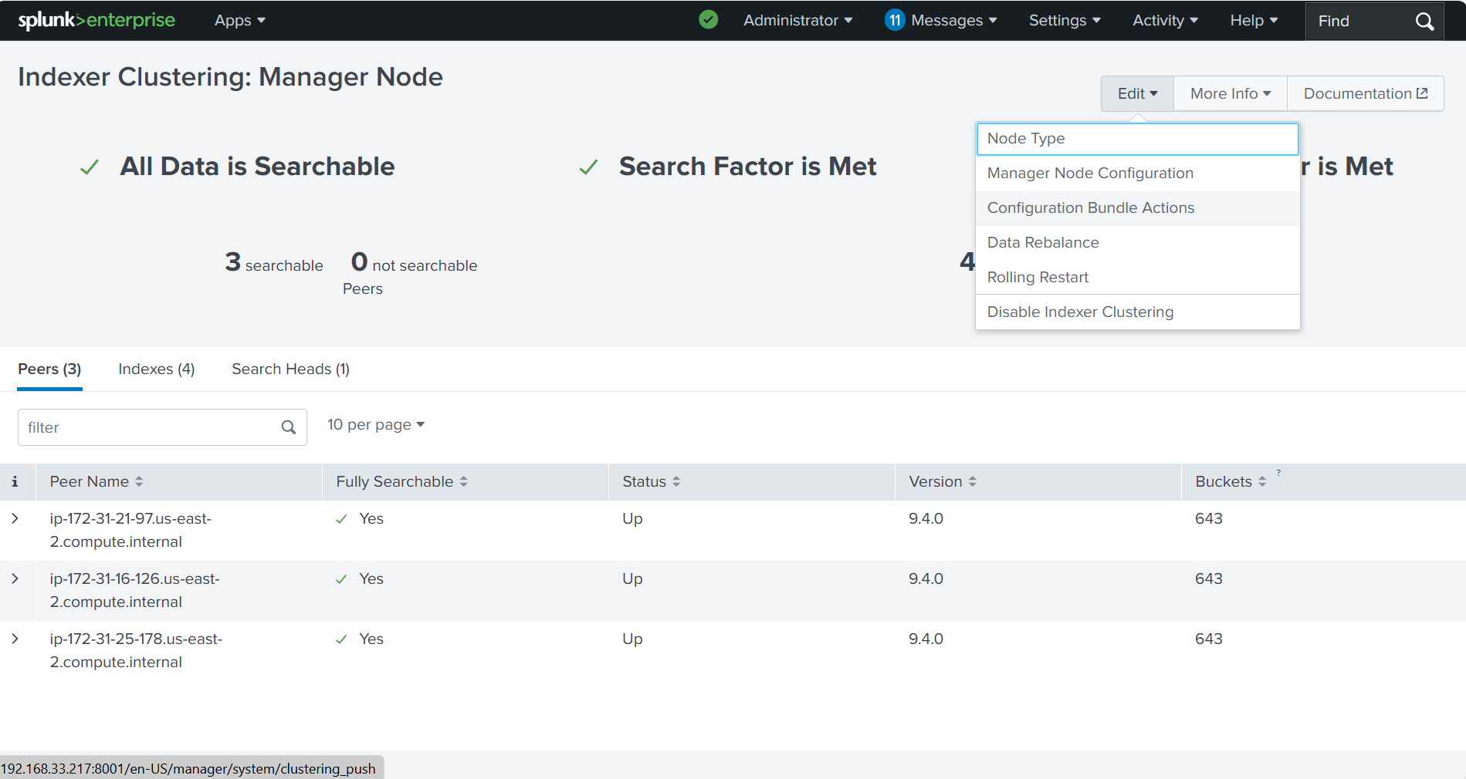

- Click "Validate and Check Restart"

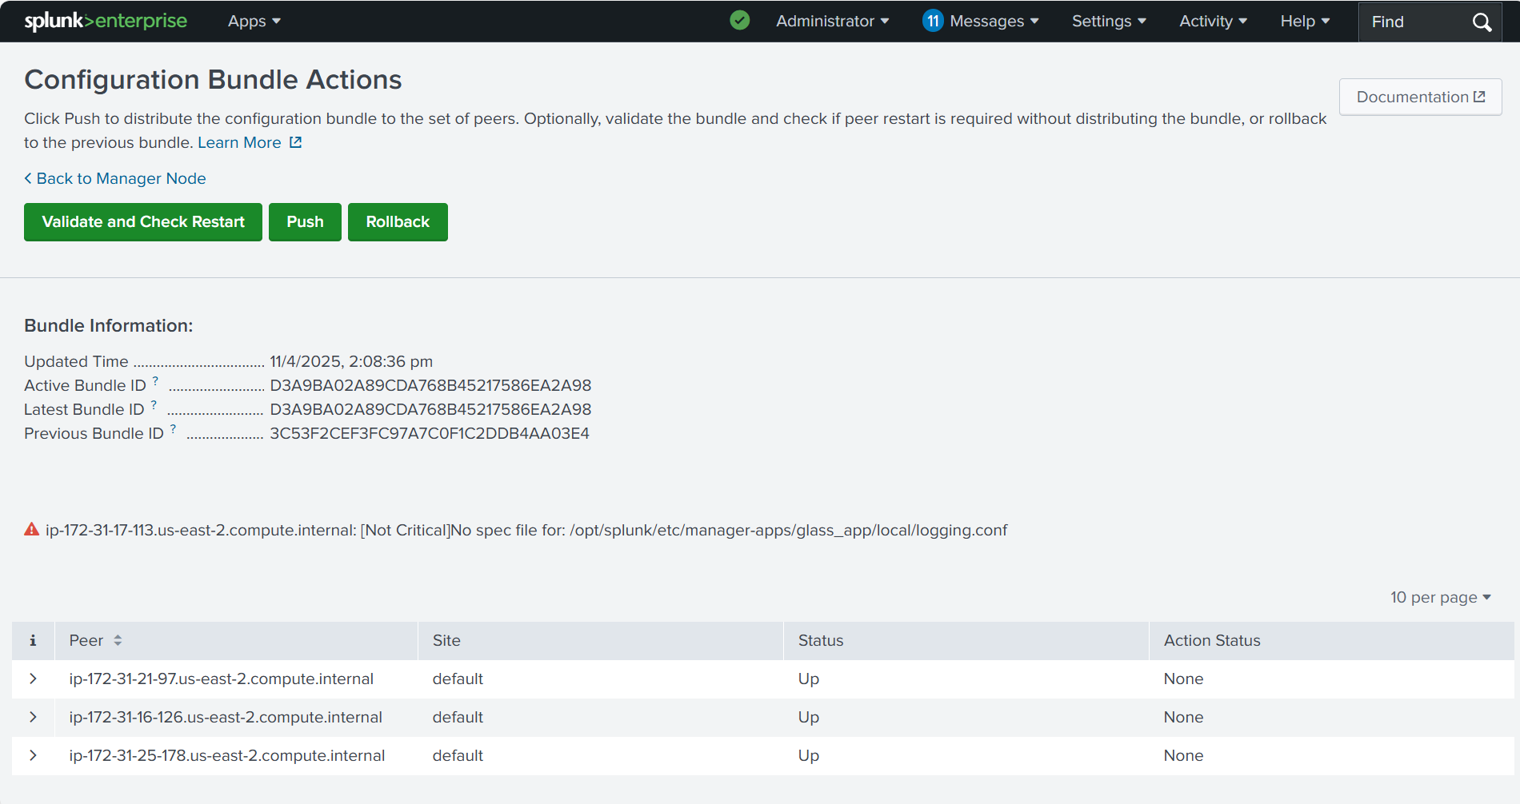

- Once the validation is successful click on "Push"

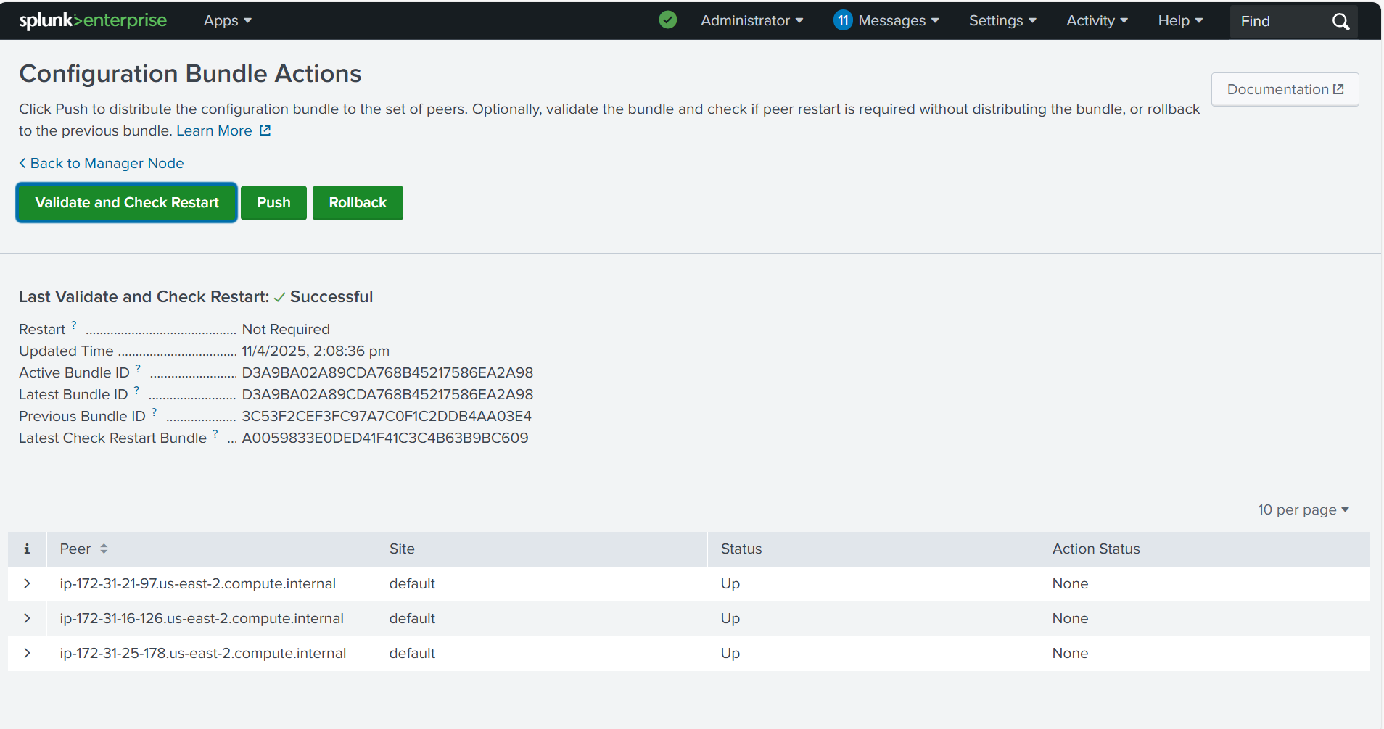

- After successful deployment to all the Peer nodes, please restart all the Peer nodes. The Glass app will be available on the Peer nodes at path /etc/peer-apps/

Deploy the Glass app to Search Head Node
Please follow the steps given in the section “3.1 On Splunk Single Instance Setup” to deploy the Glass App on Search Head node if there is a single Search Head node.
In case of Search Head Cluster, use the Search Head deployer to deploy the app.
Note: In case of Splunk Cluster, configuration added on the setup page should be same on Peer nodes as well as Search Head Nodes.
Configuration for the Peer nodes should be done from the Master Node only.

Usage Instructions

Opening the Glass App on Splunk UI
- Login to Splunk instance and select the Glass app
11. Select the Glass app

- After Glass app selection, you will be directed to Glass App Home page
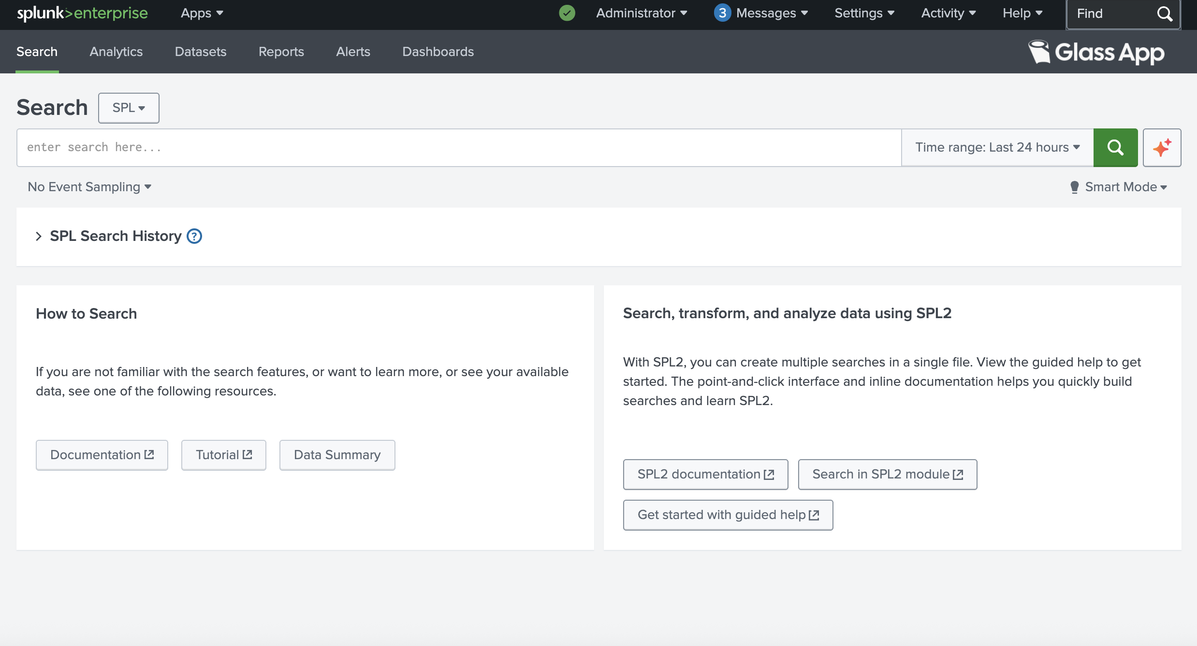

- Run the Glass app commands to use its features
  - Command to archive the data from Splunk frozen directory to Remote Long-term Storage
| archive

  - Command to list the buckets for all the indexes which are archived. It helps to explore before performing the restore.
| catalog --from_date="2026-01-01 00:00:00" --to_date="2026-01-31 23:59:00"

  - Command to list all buckets for a specific index which are archived. It helps to explore before performing the restore.
| catalog --from_date="2026-01-01 01:00:00" --to_date="2026-12-31 23:59:00" --index=index_name

  - Command to restore the archived buckets for the given time window for all the indexes.
| restore --from_date="2026-01-01 00:00:00" --to_date="2026-01-31 23:59:00"

  - Command to restore the specified multiple archived buckets for the given time window and the specified index.
| restore --from_date="2026-01-01 01:00:00" --to_date="2026-01-31 23:59:00" --index= index_name --buckets bucket1_name bucket2_name

Running “archive” command
Archive command is used to archive the data from Splunk Instance’s frozen directory to Remote Long-term storage (S3 compatible storage).
- To archive run the below command:
| archive
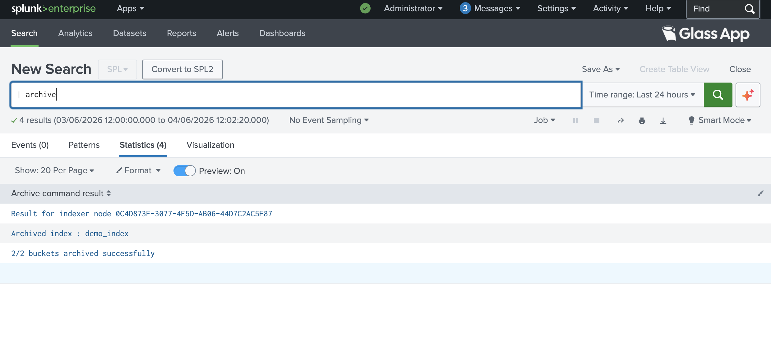

Running “catalog” command
Catalog command helps to explore before performing the restore. Following are different ways to execute catalog command.
- To list the buckets for all the indexes which are archived run the below command:
| catalog --from_date="2026-01-01 00:00:00" --to_date="2026-01-31 23:59:00"

- To list all buckets for a specific index which are archived run the below command:
| catalog --from_date="2026-01-01 01:00:00" --to_date="2026-12-31 23:59:00" --index=index_name
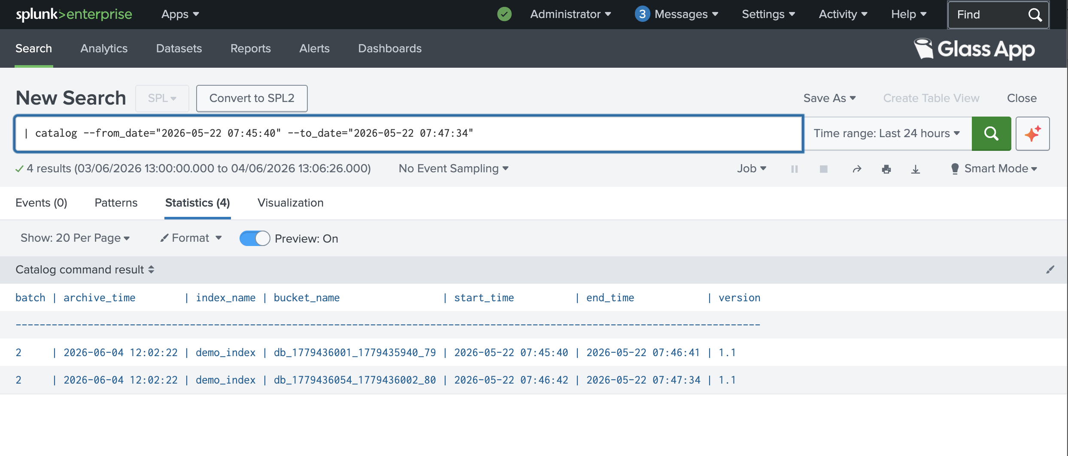

Running “restore” command
- To restore the archived buckets for the given time window for all the indexes:
| restore --from_date="2026-01-01 00:00:00" --to_date="2026-01-31 23:59:00"
- To restore the specified multiple archived buckets for the given time window and the specified index:
| restore --from_date="2026-01-01 01:00:00" --to_date="2026-01-31 23:59:00" --index= index_name --buckets bucket1_name bucket2_name

**NOTE: Restart the Splunk instance after restore.

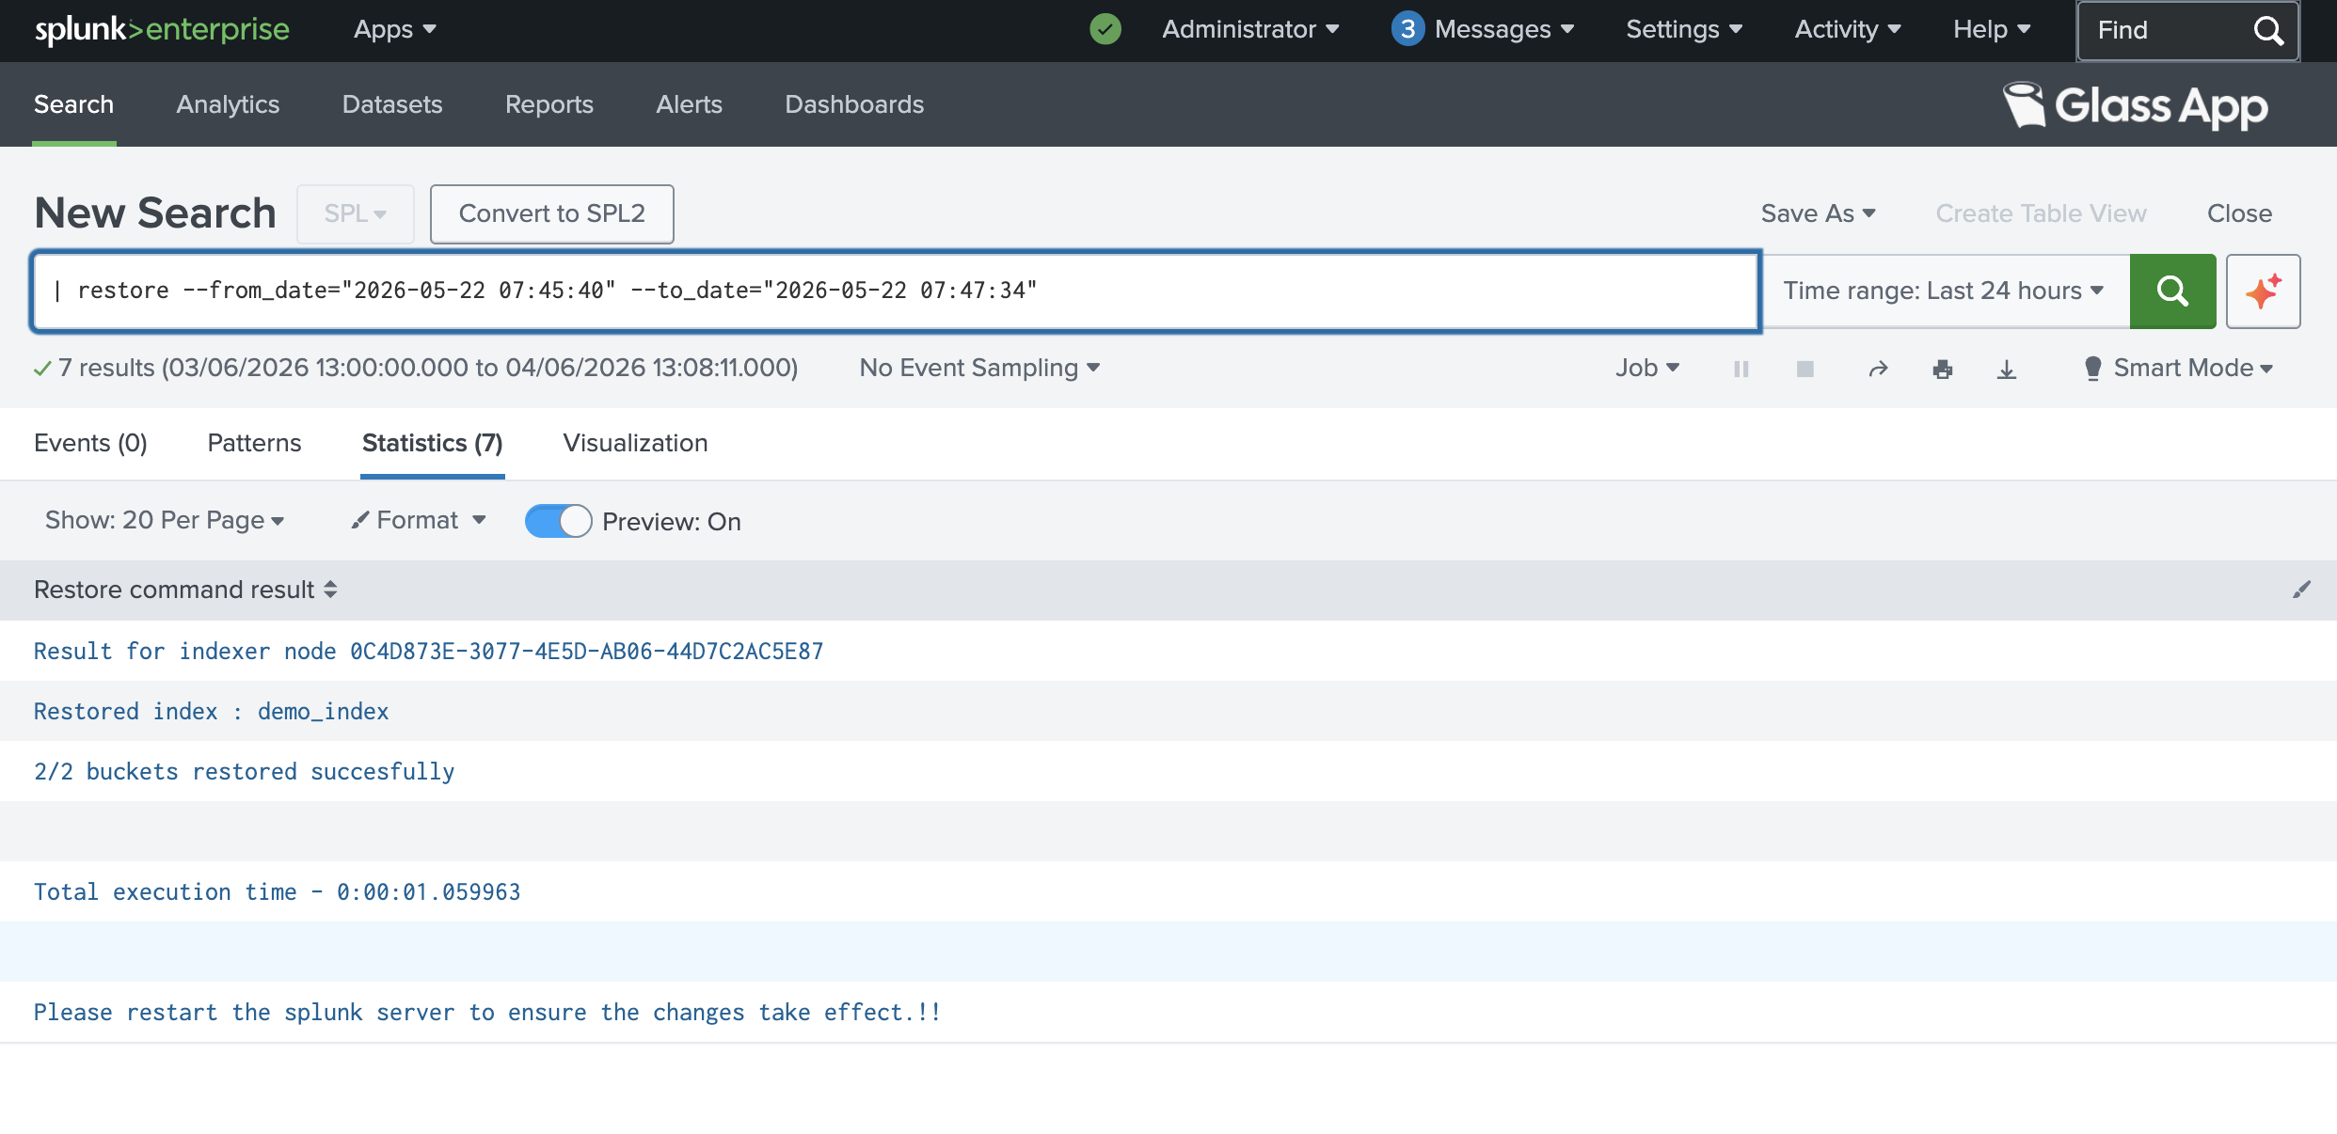

Confirming the Restored Data in Splunk

Steps to run the Splunk Search query to confirm the restored Data from Splunk Search:
- Open Splunk UI in Browser and login. Click on Apps and Select “Search and Reporting”.

- Type the below query in the Search text box and execute as shown in the below image.
index="$INDEX_NAME" | rename _bkt as bucketId| rename _cd as cd| stats count by bucketId,cd,_raw| join type=left bucketId [|dbinspect index=$INDEX_NAME] | search state="thawed" | table _raw,bucketId,state,splunk_server

**Note: Replace $INDEX_NAME with your Index Name in the above query, wherever it occurs.
**Note: Execute this query before and after the Restore command execution to compare the results and verify restore is working correctly.

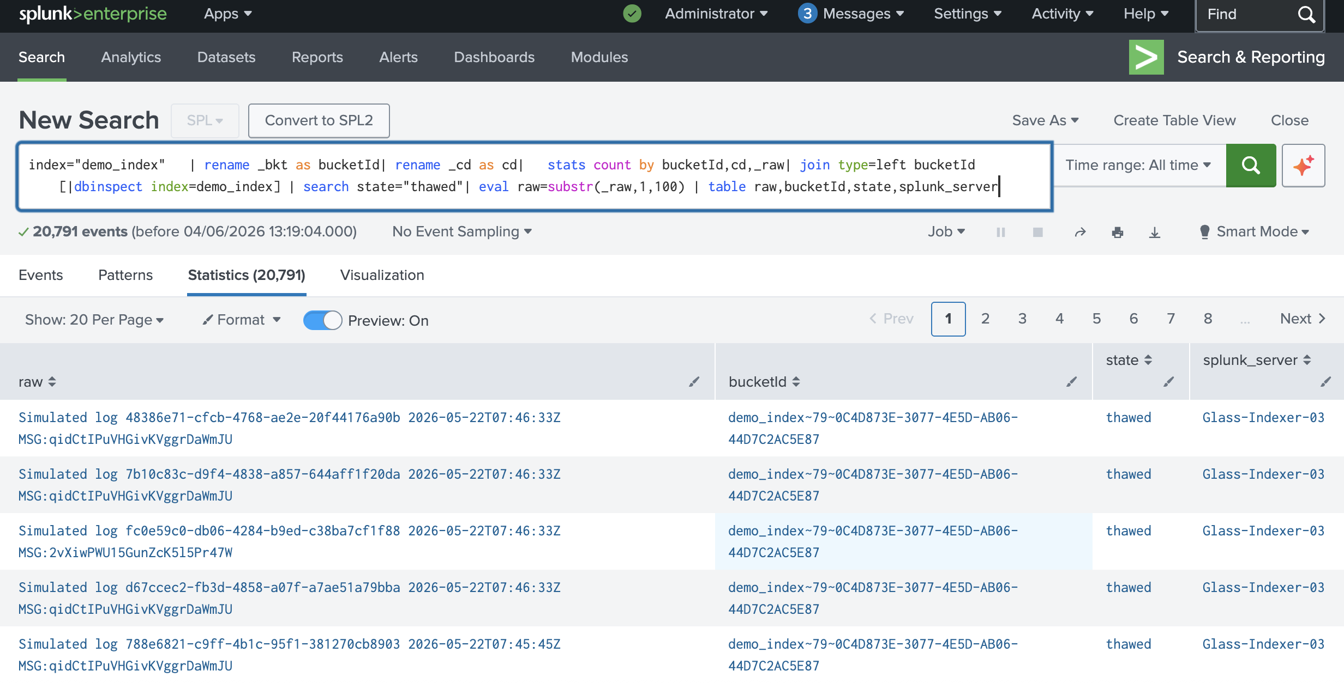

- The restored data is placed in the thawed state in Splunk. Therefore, when you run the above query after restoring data using the Glass App, the results will include records where the "state" field is set to thawed.
However, if you run the same query before restoring, the same records will not be visible in the result as that Data was archived and not searchable anymore in Splunk.

Steps to confirm the restored data from the Splunk CLI:
You can also confirm if the buckets are present in the thawed directory from the Splunk terminal after successful restore execution, at the below path:
ls $SPLUNK_HOME/var/lib/splunk/$INDEX_NAME/thaweddb
Example:
ls /opt/splunk/var/lib/splunk/demo_index/thaweddb

Operational Notes
- In case of Splunk Cluster Setup, it is recommended to execute the Glass App commands from the Search Head node, as the Search Head node will distribute the command execution on all the Peer Nodes.
- Whenever a command is executed on Search Head node, it will fetch the list of Peer Nodes from the Master Node using the Fetch Peer Details API. Then the command will be executed separately on each Peer and once the command execution completes, the cumulative result will be displayed on the Search Head node UI.
- Glass App related logs are generated at the path /opt/splunk/var/log/splunk/glass_app/ in the below log files:
- glass_setup.log – Keeps the logs for the Setup Page operations of the Glass App.
Retention Policy: stores last 10 files of 5 MB each
- glass_app.log – Keeps the logs for the Glass App command executions.
Retention Policy: stores last 10 files of 10 MB each
- Catalog DB and other Glass App related data is kept at location: $SPLUNK_HOME/var/lib/splunk/glass_app/
- In case any Peer node goes down in case of Cluster Setup the Glass DB Catalog file from the failed Peer node will be restored on the newly added replacement Peer node in the Cluster. This process will be done from the Manager node.
- Monitor the glass_catalog index size and increase its storage allocation through the Splunk UI before the configured limit is reached. This prevents data from being moved from the glass_catalog index to the frozen state.

The glass_catalog index stores metadata for archived database files which contains bucket archival information for frozen data. If this metadata is moved to the frozen database, it becomes unsearchable, and the corresponding archived buckets may no longer be restorable.
Refer to the screenshot below for instructions on updating the size of the glass_catalog index:
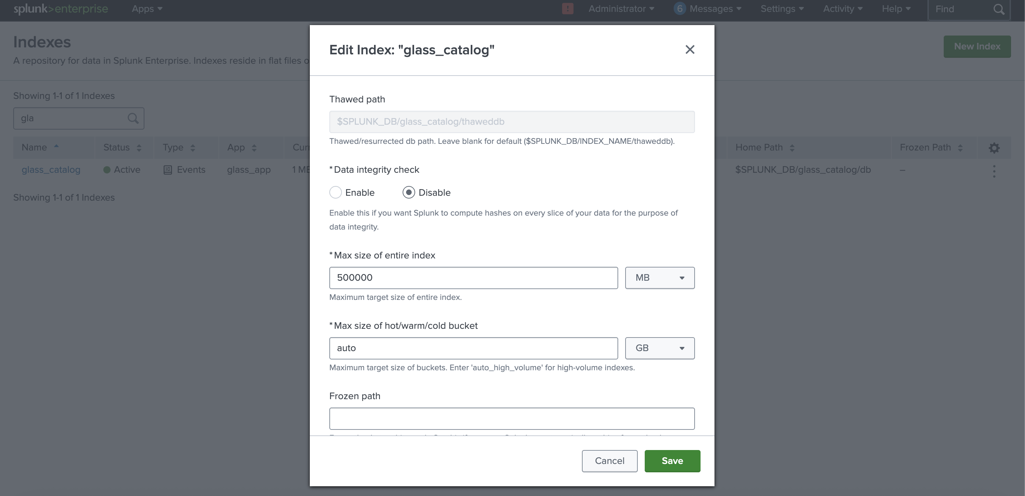

Troubleshooting

Restart Splunk instance
- Restart using UI
- Go to Splunk Web in your browser and sign in
- Select the Settings menu
- Under System, select Server controls
- Select Restart Splunk
- Select OK to confirm the restart
- Restart using CLI
- Go to %SPLUNK_HOME%/bin
- Run the command ./splunk restart

Note: - Restart using UI can sometimes take longer than expected or fail to complete. In these cases, it's recommended to perform a restart via the command-line interface (CLI)

Uninstall and cleanup

Splunk Single Instance Setup
- Go to the node’s deployment apps folder:
cd $SPLUNK_HOME/etc/apps/
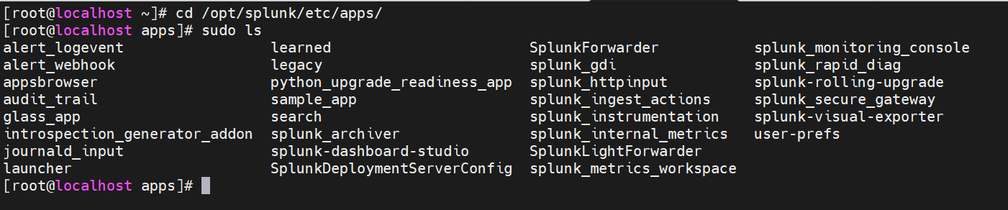
- Remove the app:
sudo rm -rf glass_app
- Remove the logs directory:
sudo rm -rf $SPLUNK_HOME/var/log/splunk/glass_app

- Remove the metadata directory:
sudo rm -rf $SPLUNK_HOME/var/lib/splunk/glass_app
- Remove the Glass Catalog files:
sudo rm -rf $SPLUNK_HOME/var/lib/splunk/glass_catalog
sudo rm -rf $SPLUNK_HOME/var/lib/splunk/glass_catalog.dat

- Restart Splunk Server

Splunk Cluster Setup

On Master and Peer Indexer Nodes
- Go to the manager/master node’s deployment apps folder:
$SPLUNK_HOME/etc/manager-apps/
or
$SPLUNK_HOME/etc/master-apps/
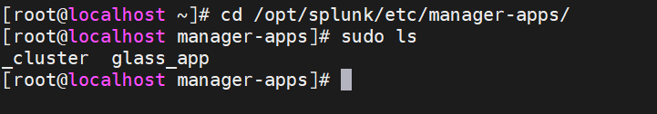
- Remove the app:
sudo rm -rf glass_app
- Push the Updated Bundle from Manager Node's UI

- After the bundle push, check indexers to confirm the app was removed:
sudo ls $SPLUNK_HOME/etc/peer-apps/
or
sudo ls $SPLUNK_HOME/etc/slave-apps/
- Remove the logs directory from Manager and Peer Nodes:
sudo rm -rf $SPLUNK_HOME/var/log/splunk/glass_app

- Remove the Glass Catalog files:
sudo rm -rf $SPLUNK_HOME/var/lib/splunk/glass_catalog
sudo rm -rf $SPLUNK_HOME/var/lib/splunk/glass_catalog.dat
- Remove the metadata directory Manager and Peer Nodes:
sudo rm -rf $SPLUNK_HOME/var/lib/splunk/glass_app
- Restart Splunk Server

On Search Head Node
Please follow the steps given in the section “7.1 Splunk Single Instance Setup” to Uninstall the Glass App on Search Head node.

Acknowledgement
- Splunk Traditional Tiered Hierarchical Archive
https://docs.splunk.com/Documentation/Splunk/9.3.2/Indexer/Automatearchiving
- Splunk Smartstore Archive
https://docs.splunk.com/Documentation/Splunk/9.3.2/Indexer/ConfigureSmartStore
- Splunk Archive Policy
https://docs.splunk.com/Documentation/Splunk/9.3.2/Indexer/Setaretirementandarchivingpolicy
- Splunk Configuration
https://docs.splunk.com/Documentation/Splunk/9.3.2/Indexer/Configureindexstorage
- Splunk App Anatomy
https://dev.splunk.com/enterprise/docs/developapps/createapps/appanatomy

